D.K. GOVT.COLLEGE FOR WOMEN (A) NELLORE

DEPARTMENT OF COMMERCE
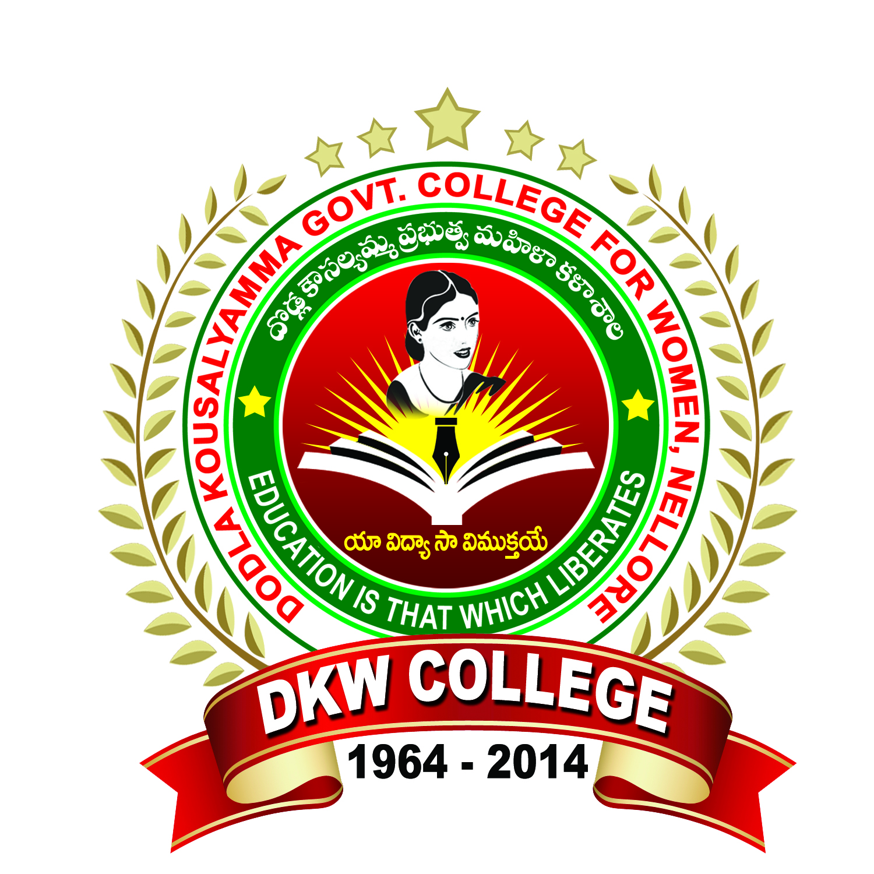
PERSONAL PROFILE
Mr. M.Premananda Babu, M.Com
FACULTY IN COMMERCE
PERFORMANCE APPRAISAL-INDIVIDUAL

Performance Appraisal Report Self Appraisal
- GENERAL INFORMATION:
- Name : M.PREMANANDA BABU
- Date of Birth : 20/07/1976
- Mailing Address :Department of Commerce
D.K. Govt. College for Women, Nellore SPSR Nellore (DT).
- Permanent Address : VEGUR VILLAGE & POST
KOVUR MANDAL,
S.P.S.R. Nellore (District) PIN-524137
- Designation : Guest Lecturer in Commerce
- Department : Commerce
- Area of Specialization :
- Date of Appointment : 21/07/2015

- ACADEMIC QUALIFICATIONS :
Exam Passed | University | Subject | Year | Division
M.Com | S.V University  Thirupati | Commerce | 1999-2001 | II

- RESEARCH EXPERIENCE AND TRAINING :
Research Stage | Title Of The Work/ Thesis | University Where The Work Was Carried Out
-- | -- | --

- Work Experience :

Course Taught | Name of the University/College/ Institution | Duration
Under Graduation | PRR &VS Govt. Degree College, Vidavaluru | 2010 -11 to 2014-15
Under Graduation | D.K. Govt. College For Women(A), Nellore | 2015-16 to till date

- Total Teaching Experience :
UG level - 12 Years

- Improvement of Professional Competence:

- Details of Refresher/Orientation Courses attended Shown in
Participation in summer institute, winter institute Annexure – III a
Workshops, seminars, symposia etc
- Details Of Innovations / Contribution In Teaching :
- Evaluation Methods : Discussions, Seminars, Tests & Quiz Programmes
- Remedial Teaching/ Student Counseling(Academic) : Taken Bridge Course / Remedial Classes and student Counseling Classes at Various Levels
- Details of participation in the following:
- University evaluation : examiner for VSU examinations
- Contribution to university :
- Paper setting : various autonomous colleges
- Membership with professional bodies:
- Extension work :
- participation in bodies of education :
Research Publications
Sl. No | Title | Author | Year
-- | -- | -- | --

Conferences, symposia, workshops, training programmes attended
Regional | State level | National level | International level | Workshops | FDP
01 | 00 | 05 | 00 | 02 | 01

Conferences Organized
Regional | State level | National level | International level | Workshops
-- | -- | -- | -- | --
Community Services:
Actively conducted consumer’s day celebration and make awareness of consumers about the goods. Participated in the AIDS awareness programmes organized by the NSS unit and Red Ribbon Club of our college and participated in the Rally and create awareness among the students and people of Nellore town. Participated in the HAR GHAR THIRANGA rally to create national integrity among the students.
Participated in the Swatch Bharath and Clean and Green Programme held in the College campus..

Sri. M.Premananda Babu
Mobile No: 9966119104
Email id: mpremanandababu@gmail.com

